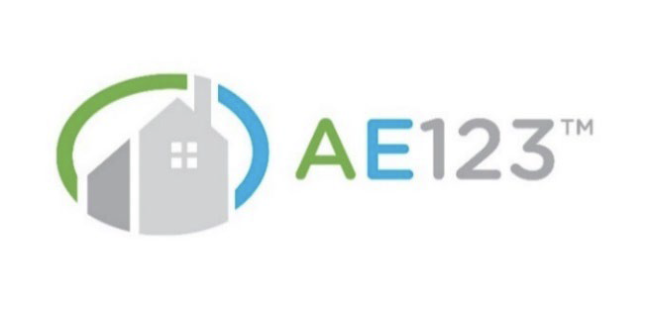
Architects & Engineers Quick-Rate Application Questions

Step 1: Determine if your firm qualifies for AE123 (Yes or No)
Your Firm:
- Is a licensed consulting design firm working on residential projects, commercial office/mixed use projects, or public funded projects and not located in one of the territories above.

- Has average gross annual revenues in each of the last two years under $250,000 per year.

- Is NOT a structural, geotechnical, soils, process, chemical, nuclear, marine, product design, machinery/equipment, or environmental firm.

- Has no ownership interest in an entity performing construction, manufacturing, or product design

- Has no more than one (1) professional liability claim in the last five years, and the total expenses and damages were under $25,000

- In the last five years generated no more than 25% of billable hours related to inspection as a standalone service

- In the last five years has not worked on a project related to Stadiums, Jails, Parking Structures, or Bridges spanning more than 250 feet

- In the last five years has not performed work on a project that had:
- Construction values over $25 million
- Multi-unit residential capacity over 25 units
- For a school district with population over 25,000

Step 2: Quick-Rate Your AE123 Policy Premium
Question 2.1 What number best approximates the average annual receipts for your firm over each of the last two years?

- $50,000
- $75,000
- $100,000
- $125,000
- $150,000
- $175,000
- $200,000
- $225,000
- $250,000

Question 2.2 How would you best describe your firm's professional discipline focus over the last two years?

- Architect
- Planner/Interior Design/Land Surveyor
- Civil Engineer with up to 25% Structural Engineering
- Civil Engineer with up to 25% Surveying or Environmental Consulting
- Mechanical / Electrical / HVAC Engineer

Question 2.3 How would you best describe your firm's project types over the last two years?

- Mostly Residential (>75%) with a modest amount of Commercial/Public
- Roughly half Residential and half Commercial/Public
- Mostly Commercial/Public (>75%) with a modest amount of Residential

Question 2.4 For how many years has your firm maintained continuous professional liability coverage?

- None
- One
- Two
- Three
- Four
- Five or more

Question 2.5 What is your State and Territory?

Question 2.6 How many professional liability claims has your firm reported in the last five years?
- 0 (other than pre-claims closed with no pay)
- 1 (for a maximum $25,000)

Question 2.7 What percent of your projects are delivered under written agreements?
- 10% or less
- 11% to 50%
- 51% to 90%
- 90% or more

Question 2.8 Approximately what percentage of your firm's client contracts contain a Limitation of Liability provision capping your liability?
- 25% or less
- 26% to 50%
- 51% to 75%
- 76% or more

Question 2.9 Approximately what percentage of your firm's contracts or agreements are either standard AIA/EJCDC or reviewed by an outside professional?
- 25% or less
- 26% to 75%
- 76% or more

Question 2.10 Select your Professional Liability Limit
- $100K/$100K
- $100K/$250K
- $250K/$250K
- $250K/$500K
- $500K/$500K
- $500K/$1M
- $1M/$1M
- $1M/$2M

Additional Coverages
- Would you like to purchase General Liability Coverage?

